**TEST 2: SMF PDU SESSION ESTABLISHMENT**

**REFERENCE STANDARD:** 3GPP TS 23.502 ,TS 29.502

**LAYER:** 5G CORE (SMF)

**DIFFICULTY LEVEL:** INTERMEDIATE

SUBMITTED BY:

## GROUP 3 - TEAM MEMBERS:

## 55984_Vikas Srivastava

## 58622_Harshinie M

## 58623_Shreyash Bhatt

## 58624_Jayavarshini G

## 58635_Yuvaraj P

|  |
| --- |
| **TABLE OF CONTENTS** |

|  |  |  |
| --- | --- | --- |
| **S.NO** | **DESCRIPTION** | **PAGE NO** |
| **1** | Introduction to SMF & PDU Sessions | 3 |
| **2** | 5G Core Architecture | 4 |
| **3** | PDU Session Establishment Signaling Flow | 6 |
| **4** | SMF State Machine | 8 |
| **5** | C++ Implementation | 9 |
| **6** | Sample Output | 20 |
| **7** | Key Concepts & 3GPP References | 22 |
| **8** | Compilation Guide | 24 |
| **9** | Conclusion | 25 |

# **1. INTRODUCTION TO SMF & PDU SESSIONS IN 5G NR**

The Session Management Function (SMF) is a key control-plane Network Function in the 5G Core (5GC) architecture. It is responsible for managing the complete lifecycle of PDU (Protocol Data Unit) Sessions, which provide end-to-end data connectivity between the User Equipment (UE) and external Data Networks (DNs) such as the Internet, IMS, and enterprise services.

A PDU Session represents a logical association between the UE and a specific Data Network, identified by a Data Network Name (DNN) and a Network Slice (S-NSSAI). The SMF establishes, modifies, and releases these sessions, while coordinating with other core network functions including the AMF (Access and Mobility Management Function), UPF (User Plane Function), PCF (Policy Control Function), and UDM (Unified Data Management).

Through its central role in session control, the SMF ensures proper IP address allocation, QoS enforcement, traffic steering, and seamless connectivity for 5G services across different slices and access technologies.

**3GPP Reference**

The procedures governing PDU Session establishment, modification, and release in the 5G System are specified in 3GPP TS 23.502, which defines the end-to-end control-plane signaling flows and interactions among core network functions such as AMF, SMF, and UPF. The service-based architecture and Session Management Function (SMF) operations are further detailed in 3GPP TS 29.502, which specifies the Service-Based Interface (SBI) APIs and service operations exposed and consumed by the SMF for PDU Session lifecycle management within the 5G Core network.

# **SMF Key Responsibilities**

The **Session Management Function (SMF)** is responsible for the complete control-plane management of PDU Sessions in the 5G Core. It handles the entire session lifecycle from creation to release and ensures that user data flows are correctly established, controlled, and optimized. One of its primary responsibilities is **PDU Session establishment, modification, and release**, including the handling of UE requests and network-initiated changes. The SMF allocates and manages **UE IP addresses** (IPv4, IPv6, or IPv4v6) and selects the appropriate **User Plane Function (UPF)** based on the requested Data Network (DNN), Network Slice (S-NSSAI), UE location, and network topology.

The SMF also performs **PFCP session management** over the N4 interface, installing and updating Packet Detection Rules (PDRs), Forwarding Action Rules (FARs), QoS Enforcement Rules (QERs), and Usage Reporting Rules (URRs) in the UPF. It creates and manages **QoS Flows**, maps them to Data Radio Bearers, and enforces Session **AMBR (Aggregate Maximum Bit Rate)** limits. In addition, the SMF handles **Downlink Data Notification (DDN)** procedures, supports **roaming scenarios** using the V-SMF / H-SMF architecture, and integrates with charging, lawful intercept, and policy control functions to ensure compliant and optimized service delivery.

**2. 5G Core Architecture - SMF Role**

In the 5G Core Service-Based Architecture (SBA), the SMF acts as the central session control entity that orchestrates all user-plane behaviour. It sits between the access and user-plane functions and coordinates with multiple network functions to deliver end-to-end connectivity. The SMF communicates with the AMF over the N11 interface for NAS Session Management signaling, with the PCF over the N7 interface for policy and QoS rules, and with the UDM over the N10 interface to retrieve subscription and session-related data. It controls the UPF via the N4 interface using the PFCP protocol, enabling the setup, modification, and teardown of user-plane tunnels and forwarding rules.

Through these interactions, the SMF ensures that traffic is routed correctly, QoS requirements are enforced, and PDU Sessions are maintained across mobility events and service changes. Its central role allows the 5G Core to support advanced features such as network slicing, edge computing (MEC), and service continuity, making the SMF a key enabler of flexible, scalable, and high-performance 5G services.

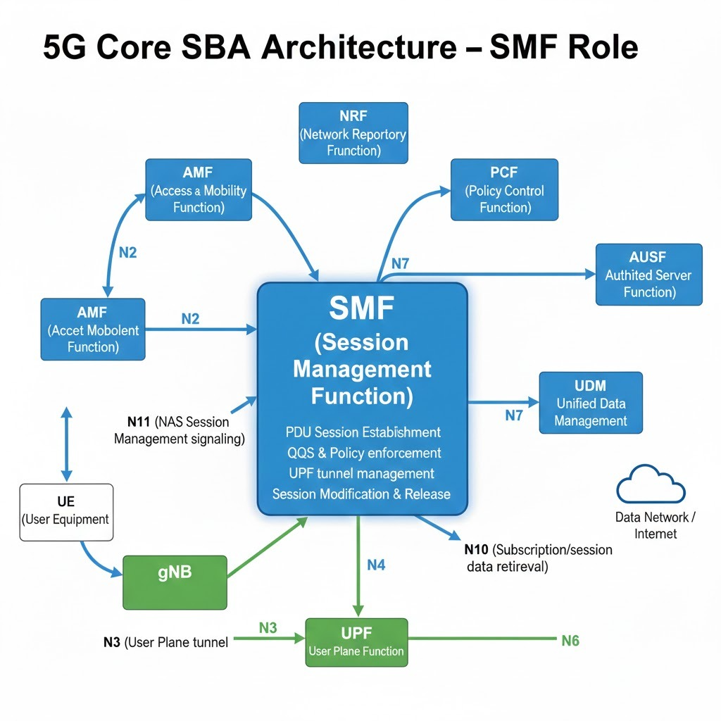

**3. PDU Session Establishment Signaling Flow**

The PDU Session Establishment procedure defines how a UE requests and receives data connectivity to a specific Data Network (DN) in the 5G system. This procedure is standardized in 3GPP TS 23.502 and involves coordinated signaling between the UE, AMF, SMF, PCF, UDM, and UPF.

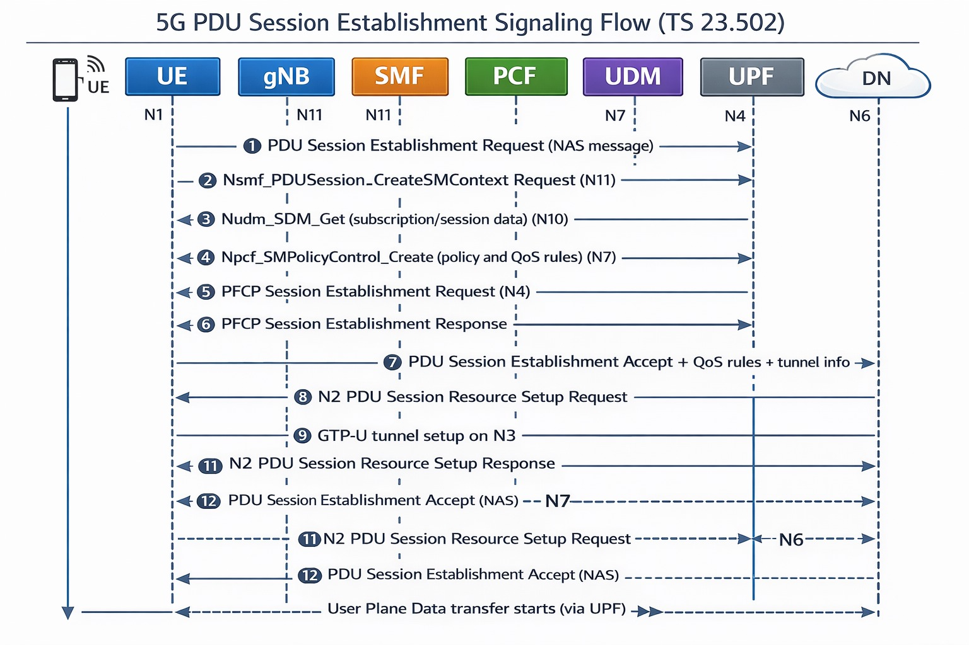

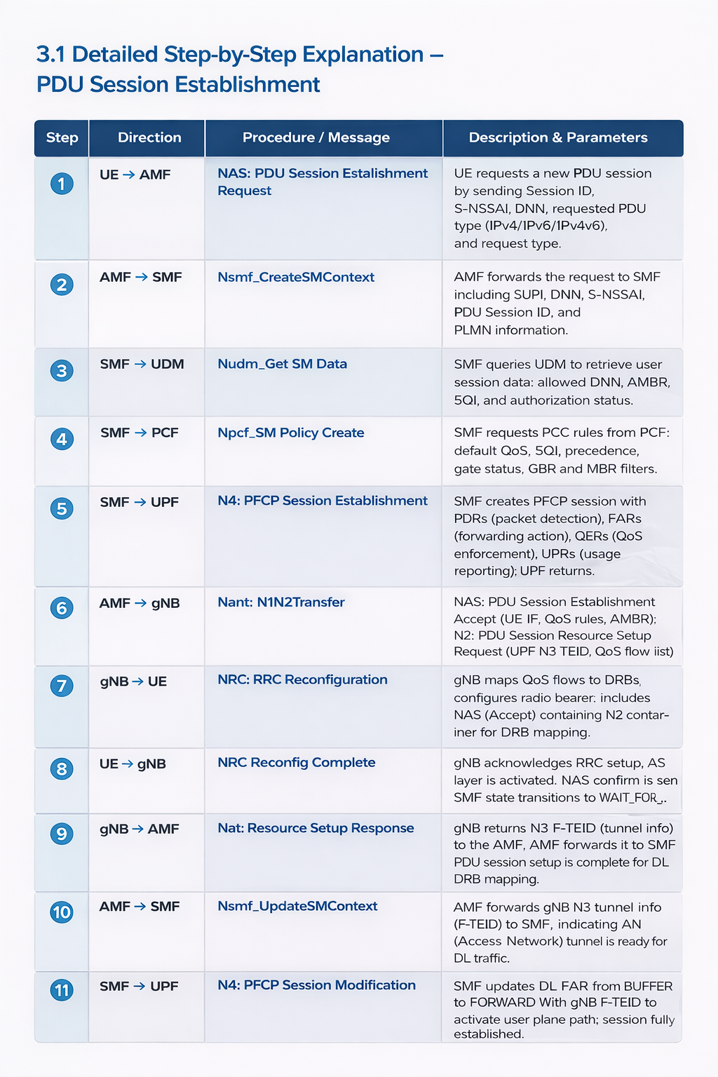

**4. SMF PDU Session State Machine**

The SMF PDU Session State Machine describes how a PDU Session transitions through different states during its lifecycle, from creation to termination. The SMF controls these state transitions based on UE requests, network policies, and control-plane signaling defined in 3GPP TS 23.502.

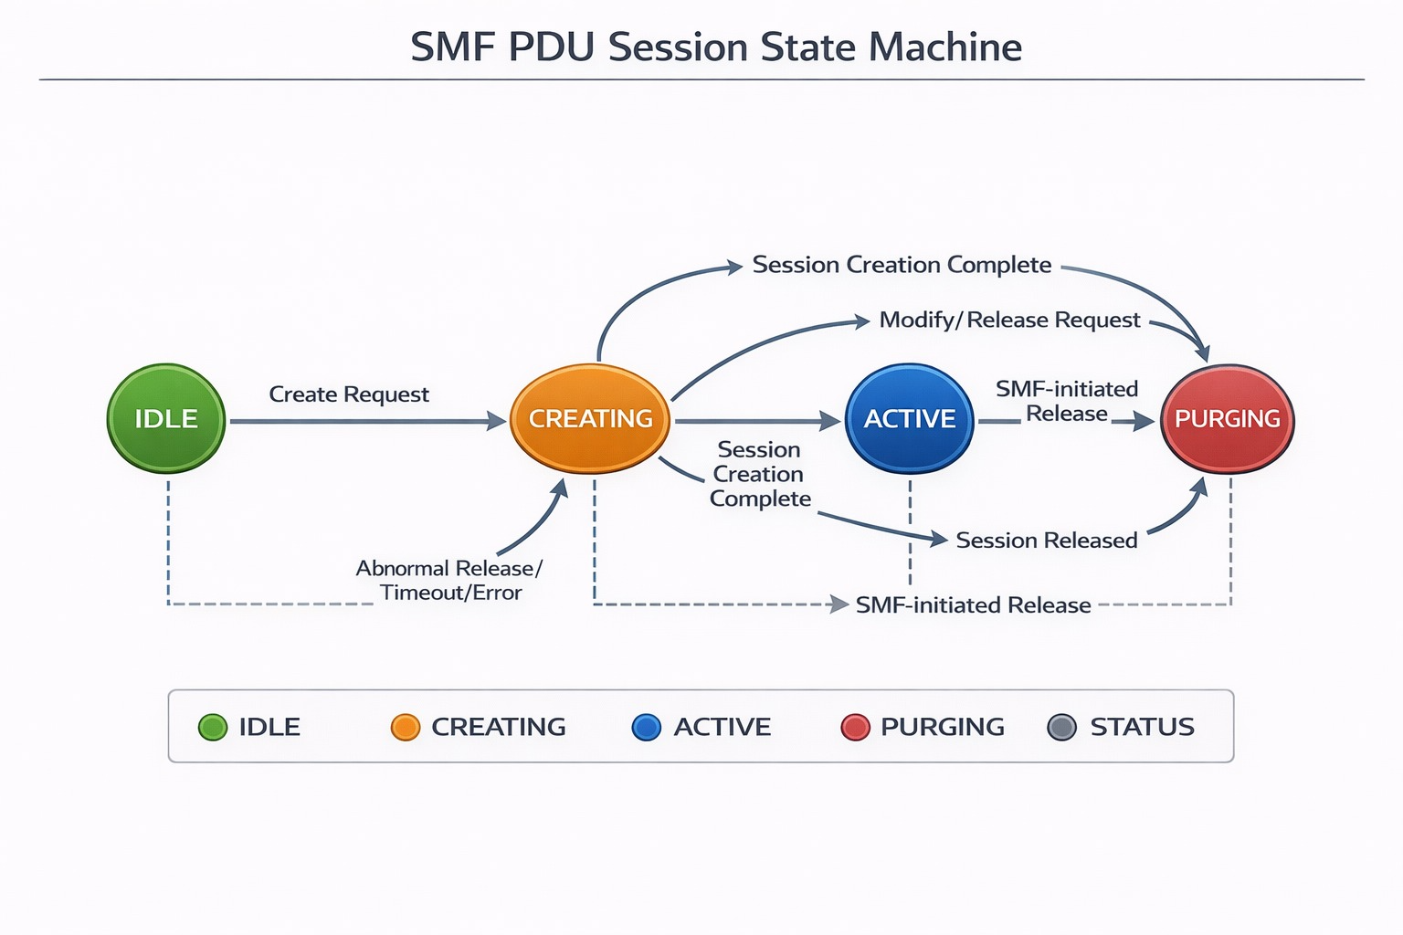

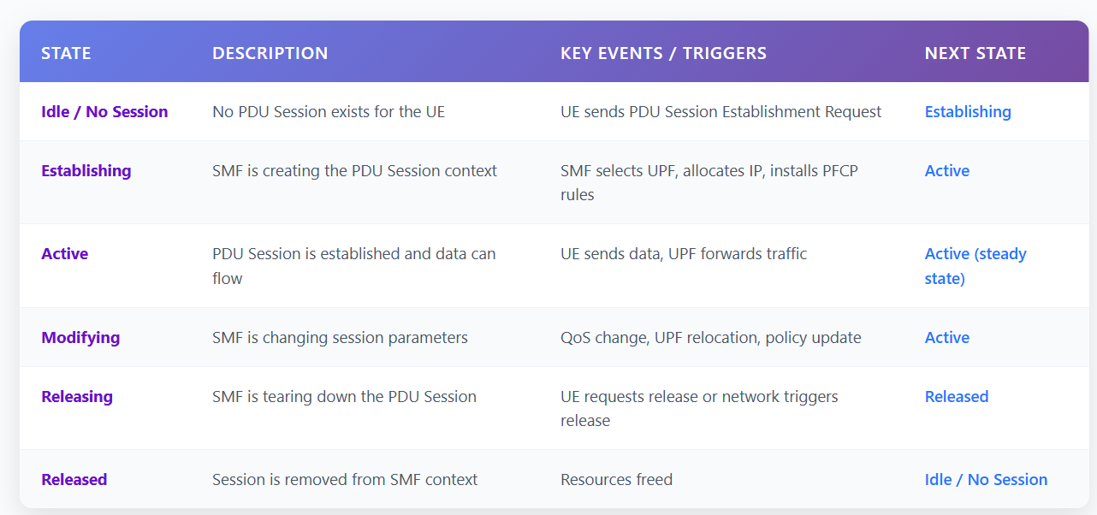

# **5. C++ IMPLEMENTATION**

**5.5 Step 1: Enumerations & Type Definitions**

Defines the basic enumerations required for the SMF PDU Session Establishment simulation. It includes PDU Session types such as IPv4, IPv6, IPv4v6, Ethernet, and Unstructured sessions, request types used during session procedures, and the PDU Session state machine representing different SMF states from IDLE to ACTIVE and RELEASED.

It also defines standard 5QI values based on 3GPP TS 23.501, which represent QoS characteristics like latency and priority for different service types. A helper function is implemented to convert session states into readable strings for logging and debugging during simulation.

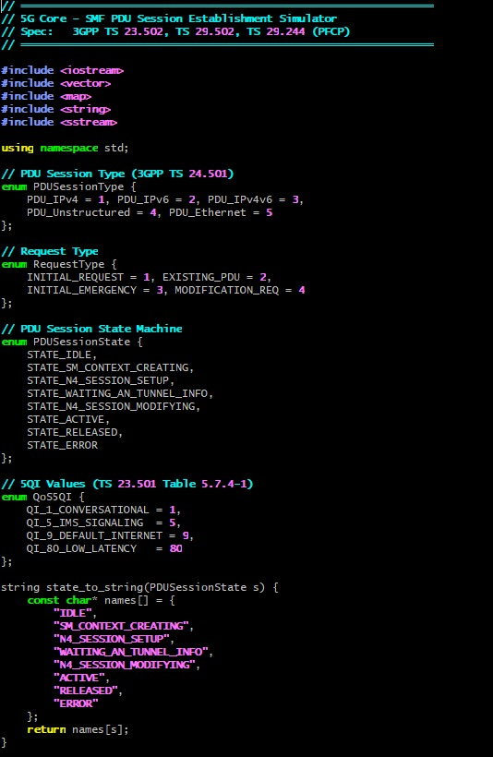

**5.2 Step 2: Core Data Structures**

Defines the main data structures required for SMF PDU Session handling. It includes S-NSSAI for network slicing, F-TEID for GTP-U tunnel identification, QoS Flow parameters, Session AMBR, and PFCP rules such as PDR, FAR, and QER. The PDU Session Context acts as the central structure maintained by SMF to store session state, QoS flows, tunnel information, and policy rules during the session lifecycle.

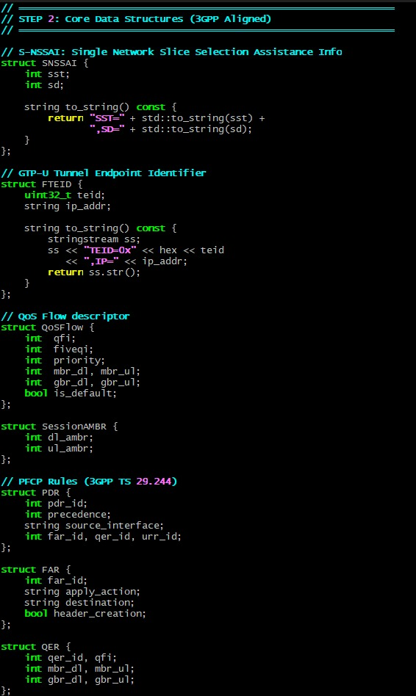

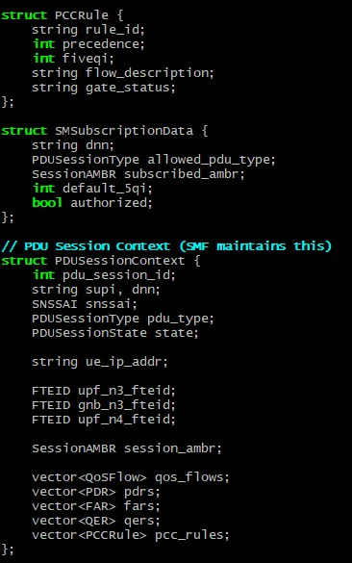

**5.3 Step 3: Network Function Simulators (UDM, PCF, UPF)**

Simulates the interaction between SMF and other 5G Core network functions during PDU Session Establishment.

* UDM (Nudm_SDM_Get) – Provides subscriber data such as allowed PDU session type, subscribed AMBR, default 5QI, and authorization status.
* PCF (Npcf_SMPolicyControl_Create) – Generates policy decisions and PCC rules used for QoS flow creation and traffic control.
* UPF / PFCP – Performs PFCP session establishment and modification, installs PDR, FAR, and QER rules, and returns F-TEID tunnel information for user plane setup.

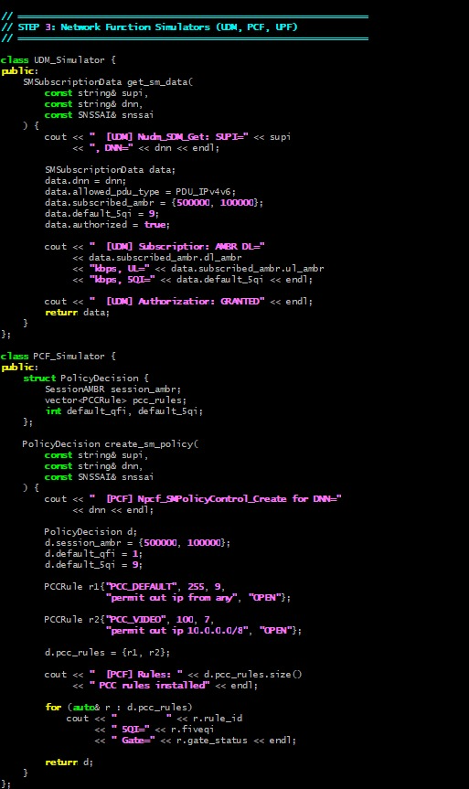

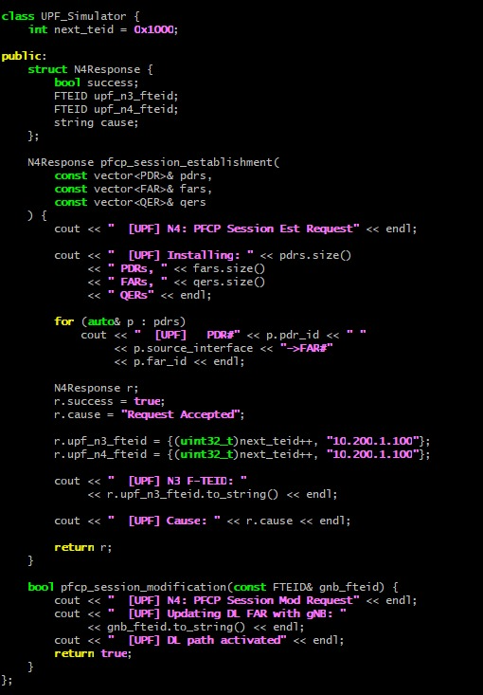

**5.4 Step 4: SMF – Session Management Function (Core Logic)**

Implements the main SMF logic responsible for handling the complete PDU Session Establishment procedure and managing session state transitions.

* SM Context Creation – Creates a new session context, stores subscriber and session details, and initiates the session state machine.
* Phase A (UDM & PCF Interaction) – Retrieves subscription data from UDM and policy rules from PCF, then creates default QoS flow and allocates UE IP address.
* Phase B (N4 / PFCP Session Setup) – Creates PFCP rules (PDR, FAR, QER) and establishes the session with UPF.
* Phase C (N1N2 Message Transfer) – Sends NAS PDU Session Establishment Accept and NGAP resource setup information to AMF.
* Phase D (Session Update) – After receiving gNB tunnel information, updates DL FAR from BUFFER to FORWARD using PFCP Session Modification and moves session to ACTIVE state.

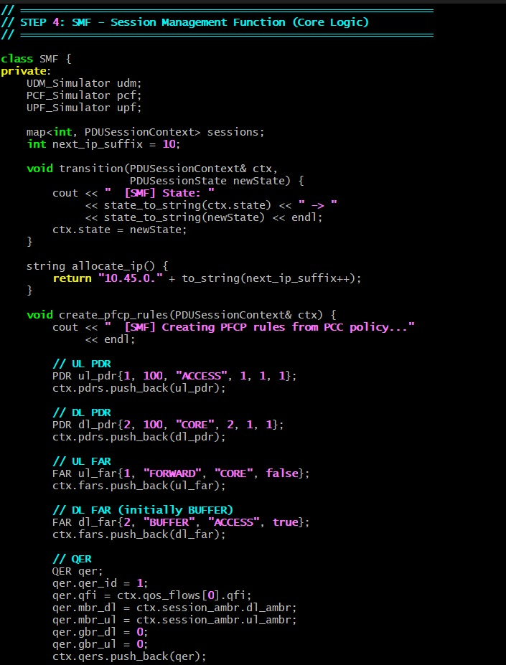

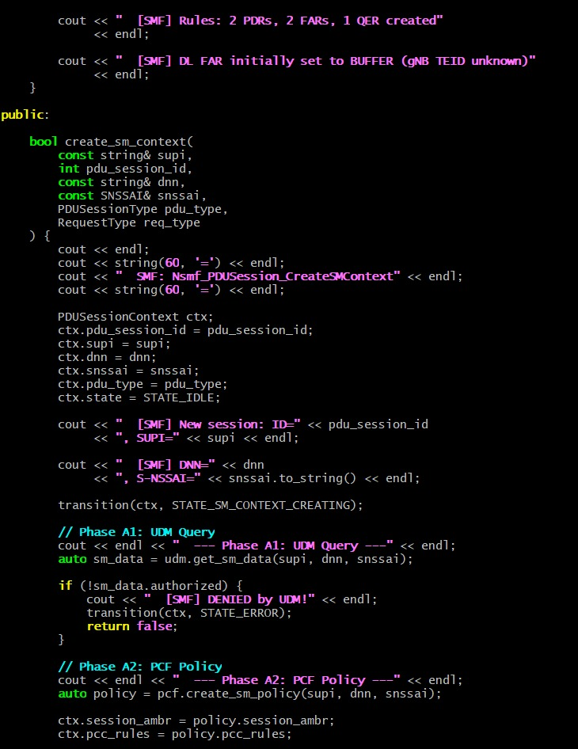

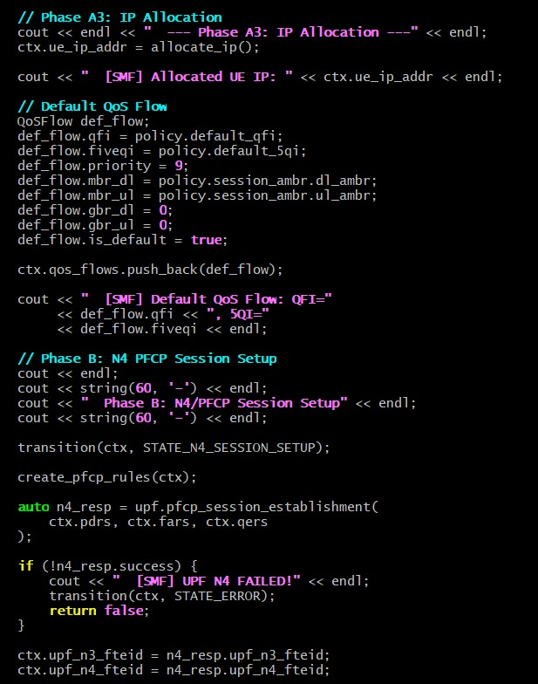

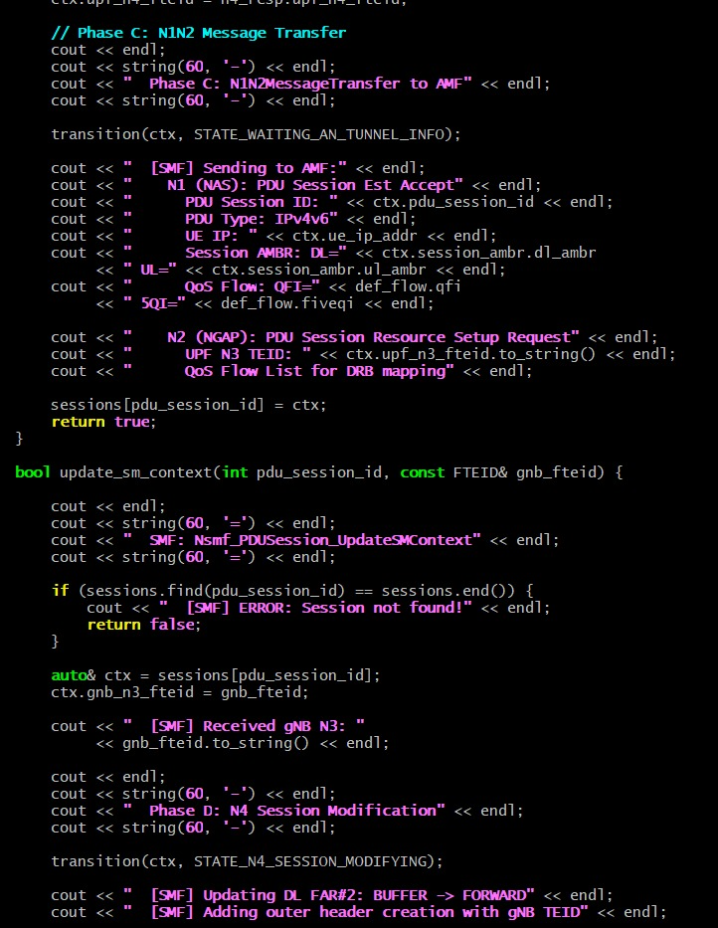

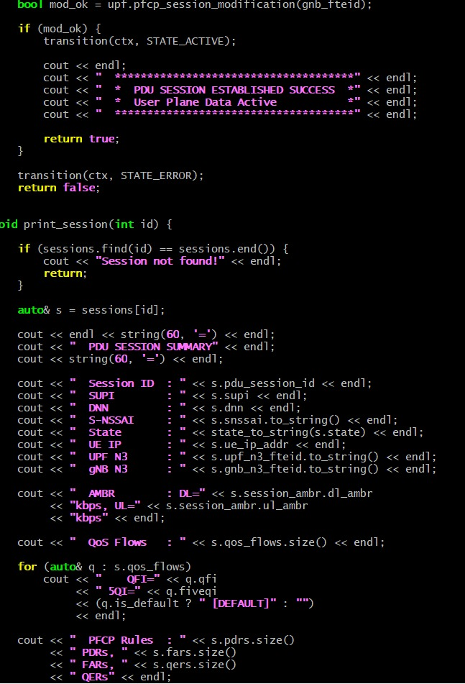

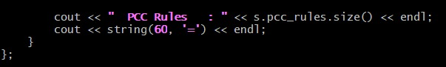

**5.5 Step 5: Main – Complete PDU Session Establishment**

Implements the main simulation flow that executes the complete PDU Session Establishment procedure. The main function creates the SMF instance, initializes the session parameters, and simulates the UE request flow from UE to AMF and then to SMF for session creation. It triggers the SMF context creation process, which performs subscription validation, policy handling, IP allocation, QoS flow creation, and PFCP session setup.

After the initial setup, the program simulates the access network procedure where gNB resource setup is completed and tunnel information is sent back to the SMF. The SMF then updates the session using PFCP modification to activate the user plane path. Finally, the program prints the PDU session summary and completes the simulation.

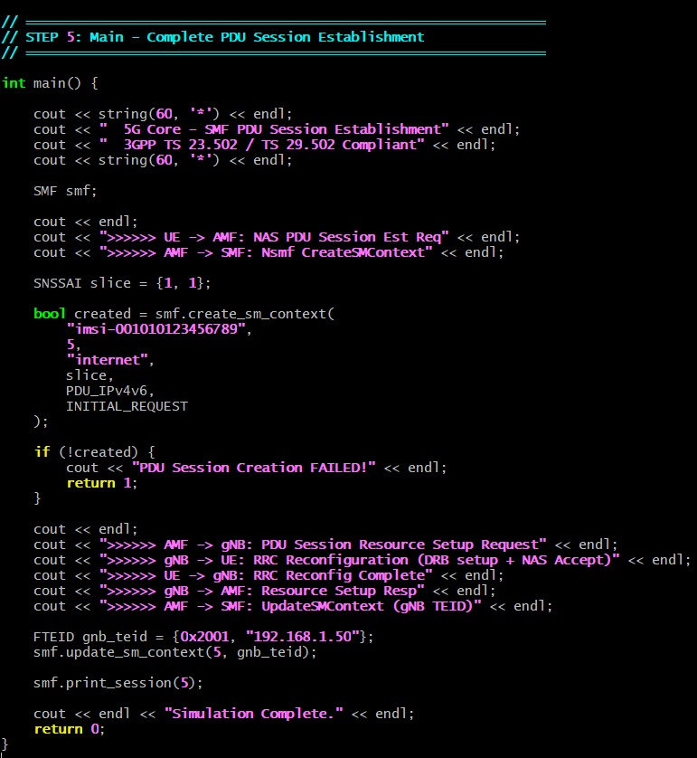

**6. SAMPLE OUTPUT**

The sample output shows the complete execution flow of the SMF PDU Session Establishment simulation. It displays the sequence of interactions between UE, AMF, SMF, UDM, PCF, and UPF, including subscription verification, policy creation, IP allocation, QoS flow setup, and PFCP session establishment. The output also shows SMF state transitions as the session moves from IDLE to ACTIVE, indicating successful control plane processing.

During the later stages, the output shows N1N2 message transfer to AMF, reception of gNB tunnel information, and PFCP session modification where the downlink FAR is updated from BUFFER to FORWARD, activating the user plane path. Finally, a PDU session summary is printed showing session details, tunnel information, QoS flows, and installed PFCP and PCC rules, confirming successful session establishment.

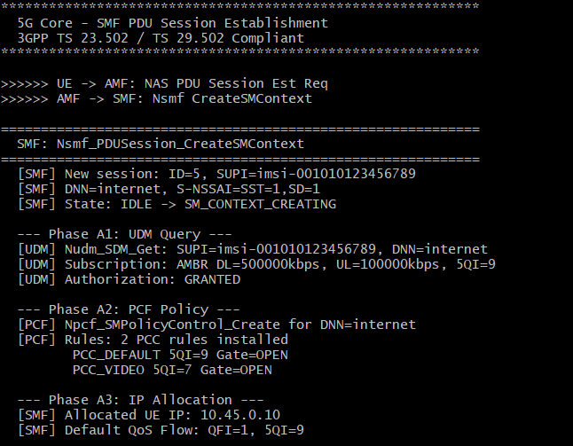

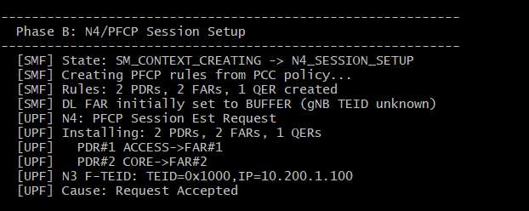

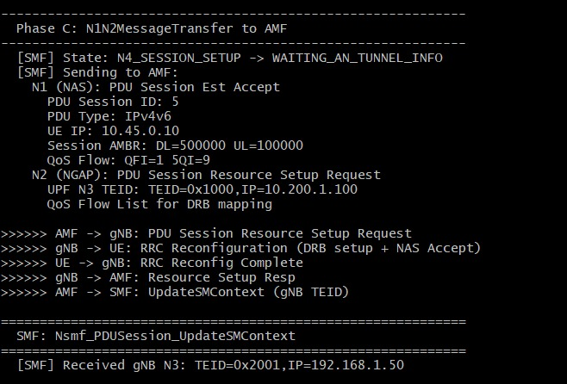

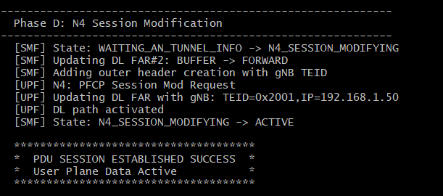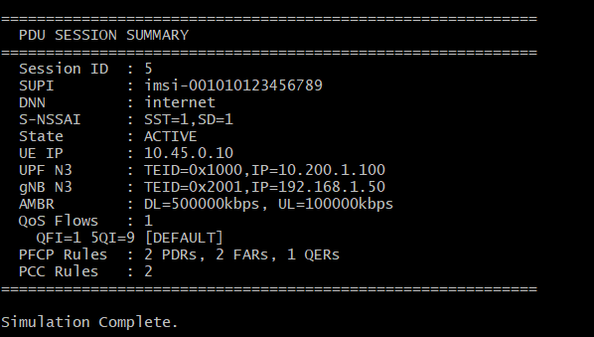

**7. KEY CONCEPTS**

**1. PDU Session**

A PDU Session is a logical tunnel between the UE and a specific Data Network (DN). It provides the UE with an IP address and enables user data to flow with defined QoS. Each session is identified by a PDU Session ID, DNN, and S-NSSAI.

**2. Session Management Function (SMF)**

The SMF is the control-plane function responsible for creating, modifying, and releasing PDU Sessions. It selects the UPF, allocates IP addresses, enforces QoS and policy rules, and controls the user plane using PFCP.

**3. User Plane Function (UPF)**

The UPF is the data-plane function that forwards user traffic between the RAN and the Data Network. It applies QoS enforcement, packet routing, and charging rules configured by the SMF.

**4. DNN (Data Network Name)**

The DNN identifies the external network the UE wants to connect to, such as the Internet, IMS, or a private enterprise network.

**5. S-NSSAI (Network Slice Identifier)**

S-NSSAI identifies the network slice requested by the UE. It allows different services (eMBB, URLLC, mMTC) to run with different performance characteristics.

**6. QoS Flow**

A QoS Flow is the finest granularity of QoS control in 5G. The SMF creates QoS flows based on PCF policies and maps them to Data Radio Bearers in the RAN.

**7. PFCP (N4 Interface)**

PFCP is the protocol used between SMF and UPF to install and manage user-plane rules such as PDR, FAR, QER, and URR.

**8. Session AMBR**

Session AMBR defines the maximum aggregated bit rate allowed for a PDU Session.

**9. NAS SM Signaling**

NAS Session Management signaling carries PDU Session control messages between the UE and AMF.

**10. Service-Based Architecture (SBA)**

The 5G Core uses SBA, where network functions expose services via APIs. The SMF consumes and provides services to AMF, PCF, UDM, and UPF.

**8. COMPILATION & EXECUTION GUIDE**

**8.1 Prerequisites :**

This simulation requires a C++11 (or later) compatible compiler. Recommended compilers include GCC 7+, Clang 5+, or MSVC 2017+. The program uses only the C++ Standard Library, so no external libraries are required.

**8.2 Compilation Commands**

* Windows (MinGW / Git Bash):

**g++ code_final.cpp -o Test2_SMF**

**./Test2_SMF.exe**

* Linux / macOS:

**g++ code_final.cpp -o Test2_SMF**

**./Test2_SMF**

* Windows (MSVC):

**cl /EHsc code_final.cpp /Fe:Test2_SMF.exe**

**Test3_RLC.exe**

**9. CONCLUSION :**

The Session Management Function (SMF) plays a central role in the 5G Core by controlling the entire lifecycle of PDU Sessions, which are the foundation of user data connectivity in the 5G system. From allocating IP addresses and selecting the appropriate UPF to enforcing QoS and policy rules, the SMF ensures that each UE receives reliable, secure, and optimized access to the required Data Networks. Through standardized procedures defined in 3GPP specifications, the SMF coordinates seamlessly with AMF, PCF, UDM, and UPF to establish, maintain, and release PDU Sessions efficiently.

By enabling flexible session control, network slicing, and service-based interactions, the SMF makes 5G networks scalable and adaptable to diverse use cases such as enhanced mobile broadband, ultra-reliable low-latency communications, and massive IoT. In essence, the SMF acts as the control-plane “brain” of 5G data services, ensuring that user traffic flows smoothly from the UE to the Data Network and back with the required performance and quality of service.